**Embedded C: Lesson 2**

* Sections of object files:

1. Uart.o

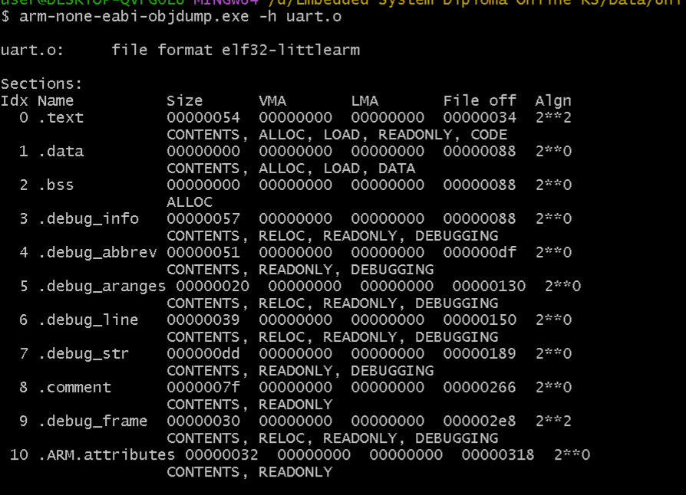

1. 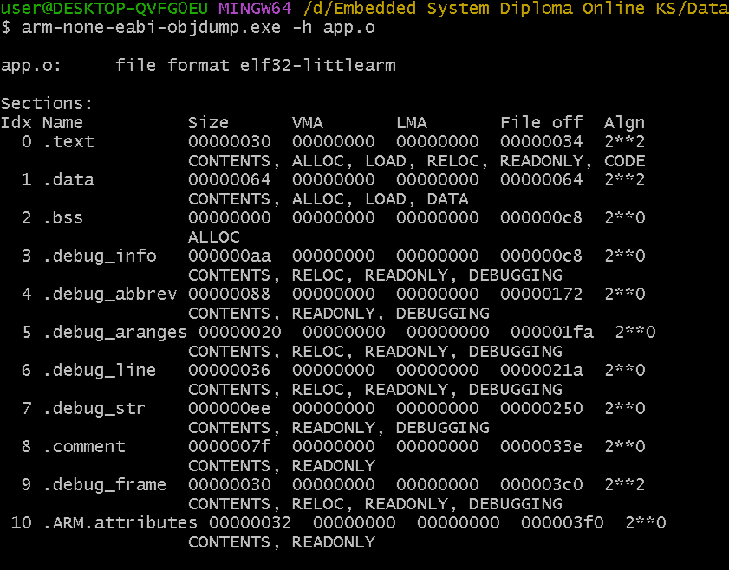App.o

Startup.o

==================================================

* Symbols Table of file.o:  
  1- uart.o  
  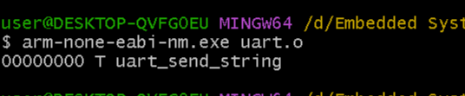

2-app.o

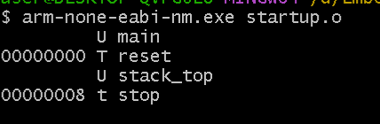3. startup.o

* 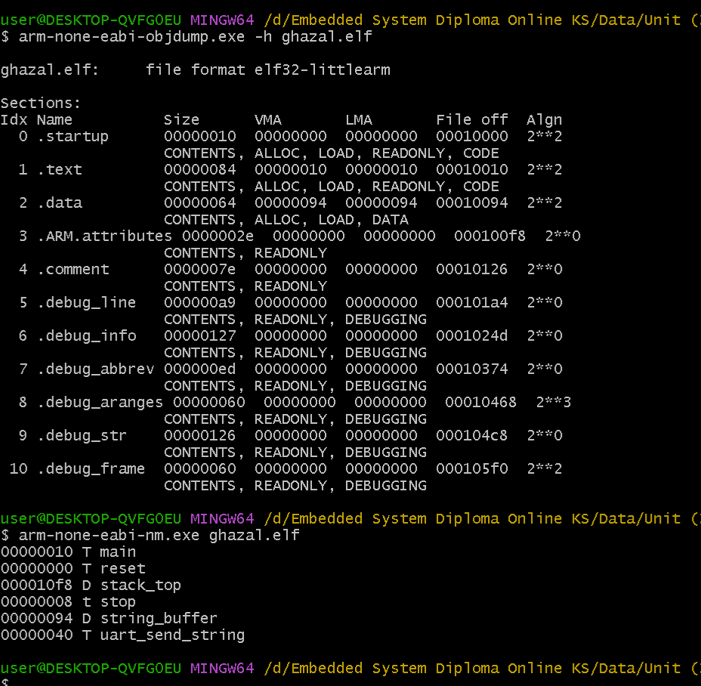Elf file